**Day 2 Lab Assignments**

1. Complete remaining assignments from prev. Lab.
   * + 1. If the value of discount is: “No discount”, hide this <h3> tag (Use structural

directive *ngIf).

(2) Make a Dropdownlist that displays the categories (Use structural directive

*ngFor).

(3) Make a table the display the Products list (Use structural directive *ngFor).

(4) Make an input where user enters his Name, and use two-way binding (Banana

operator) to bind it to “ClientName” property in the class.

(5) Make a button “Buy”, that when clicked hides the table, and shows another div

saying “Thanks for purchasing from our Store” + ClientName Entered. (use

Event binding (click), and IsPurshased flag, and method to toggle flag value,

with *ngIf, to show or hide them).

Use *ngIf on the both parts that you want to show or hide.

Instead of using *ngIf twice, use *ngIf , then, else and use ng-template to show the suitable template according to the condition (Bonus)

Note: You can use ? after object name in expression like this: {{Product?.Name}} to check if the it’s not null first.

* Unfinished Assignments to be finished next lab.

1. In your product component:
   1. For the store name display it as upper case using pipes
   2. Discount will be in percent using pipes

**Bonus:**

1. Make a custom pipe “Filter” that can be applied to an array that takes specific value and return and arry with matched elements in the array.
2. Display the products list in cards like Souq.com for example, or like the following:

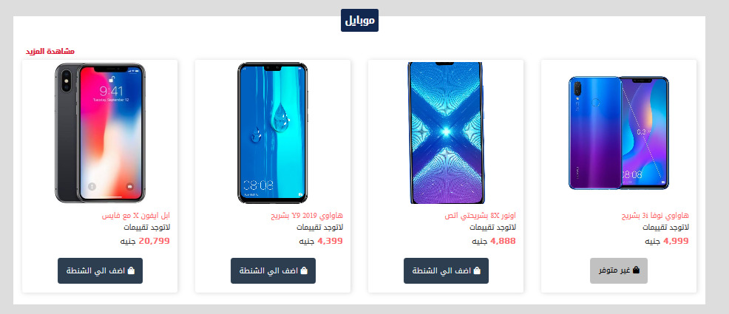

* 1. Make attribute directive that makes a border around the product, and on hover scales the image or highlight the border color.

1. Install ngx-bootstrap angular package: <https://valor-software.com/ngx-bootstrap>
   1. You can try also ng-bootstrap package: <https://ng-bootstrap.github.io/>
   2. What’s the difference between them? <https://www.techiediaries.com/angular-bootstrap-ui/>
2. Install jquery to your project, and install it types.
3. Use unit testing with your angular app.

**<Script>document.write(“Thank YOU”) </Script>**